[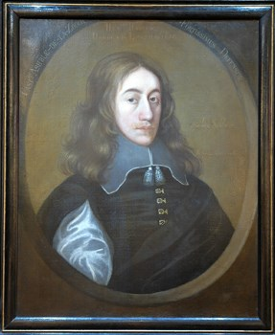](http://www.leics.gov.uk/leicsrevealed_lordhenryhastings_sm.jpg)