William Railton – Architect
An Exhibition at Loughborough Library
by Tony Jarram and Lynne Dyer
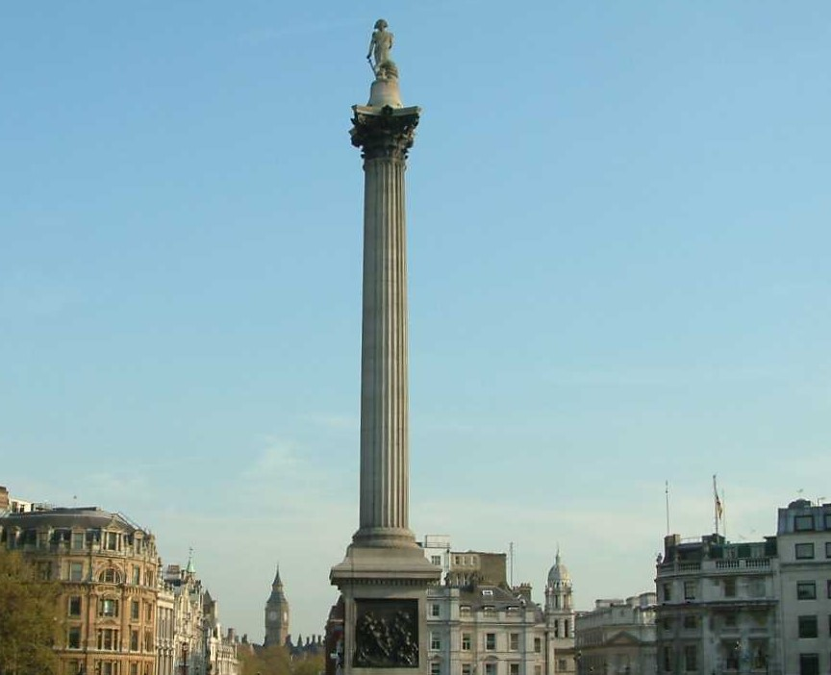
Discover Leicestershire’s Railton Buildings
7th January to 28th February 2019
Free Entry During Library Opening Hours
Nelson’s Column Photograph by Tagishsimon via Wiki Commons

