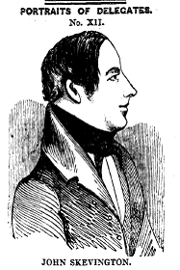
Advance Notice
Wednesday September 26th , 7pm
Swan in the Rushes, 21 The Rushes, Loughborough,
LE11 5BE
The Leicestershire Labour History Society invites you to a talk by County Councillor Max Hunt (Loughborough Co-Operative Party) on
‘From Chartists to Cooperatives in Loughborough, and the legacy of John Skevington.’
The Society’s meetings are open to everyone with an interest in working people, their organisations and their lives. (There is no requirement to be a Labour Party member to attend.).

The meeting room is upstairs – please let Mike know if you wish to attend and have mobility problems. 07798 906 754.

